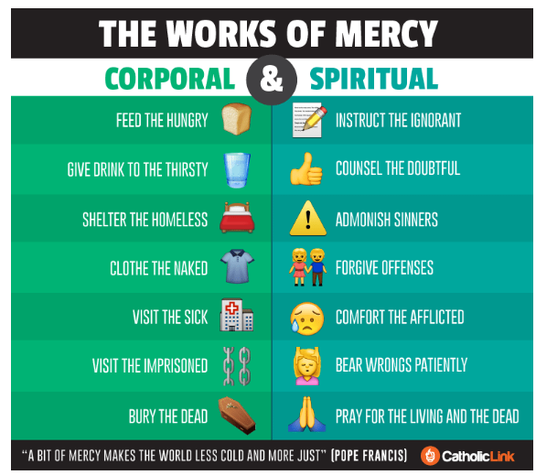

Reference: https://catholic-link.org/images/infographic-the-works-of-mercy/

